DELETION IS AN ARRAY:

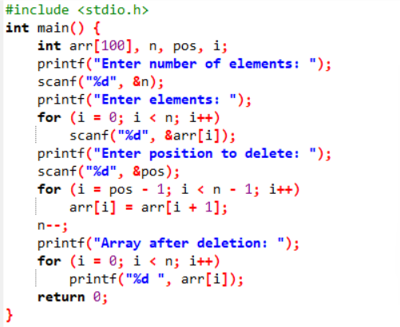

OUTPUT

